Internet Technologies Practical 2

(Kunal Sati – CSC/21/72)

#Windows

List of Connected Devices

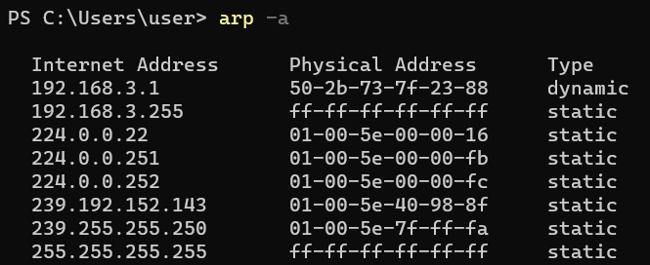

Pinging a device to check connection

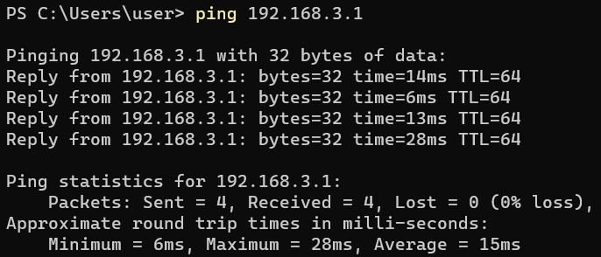

Tracing the route to the selected device

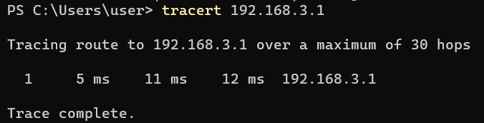

List of processes using ports for TCP protocol

